Washington Light Infantry
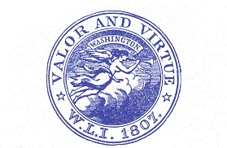
Armory 287 Meeting Street
Charleston, SC 29401
A PUBLIC READING OF THE
DECLARATION OF INDEPENDENCE
Tuesday July 4, 2023 at 9:30 AM
First Read in Charleston on August 5, 1776
The Old Exchange and Provost Dungeon
At the Foot of Broad Street
Charleston, South Carolina

Assembled by
The Washington Light Infantry of Charleston (1807)
The Old Exchange and Provost Dungeon (1771)
The City of Charleston (1670)
The Historic Charleston foundation (1947)

